Kathryn Atherton, Celine Chang, Tony Hoch, Sarah Reichstetter, Hongji Zhang

ABE 20100

Project 1 Report

3 October 2016

**Reverse-Engineering an Energy Bar**

According to NPD, 65% of the customers in 1990 check labels to determine whether the foods they buy contains anything they try to avoid. However, in 2013, this number dropped to 48%. This is a rising concern since food labels present important nutrition values that are important to consumers’ diet. In this project, the nutritional value of an energy bar on the market was evaluated and an attempt to improve it was made. In addition, the process of making this energy bar was simulated using a process flow chart.

The group was given the Gatorade brand Honey Oat Fuel Bar to examine, taste, and reverse-engineer. Dimensions of the energy bar were measured to be approximately 5 inches long, 1.5 inches wide, and 1 inch tall, with a mass of 60 grams, and a volume of 7.5 cubic inches. The appearance of the bar was very bland. The color was generally sandy-beige with a beige-yellow yogurt “icing” drizzled on top. The structure was stiff, though giving when pressed. Breaking the bar into parts for each member to taste revealed how loose and crumbly the internal structure was, compared to that of the stiff outside. Like the color, the bar flavors were bland. Though the bar flavor was called “honey oat,” no honey flavors were detected; however chalky granola and oat flavors were noted. The team also recognized banana and vanilla flavors, which most likely came from the yogurt icing. The texture of the bar was very chewy, though dry.

Table 1 lists the ingredients of the Gatorade bar, as well as their purpose.

*Table 1: Gatorade Honey Oat Fuel Bar Ingredients and Purpose*

|  |  |
| --- | --- |
| **Ingredient** | **Purpose** |
| Whole Grain Rolled Oats | Taste, structure, improves solidity |
| Crisp Rice | Taste, structure |
| Rice Flour | Texture (can make baked goods seem unique and sandy), flavor (make energy bar extra tender and crumbly with a melt-in-your-mouth feeling) |
| Sugar | Nutrition (carbohydrates, preservation (binds to water to reduce water available for growth of microorganisms), flavor, sweetness, texture |
| Malt | Texture |
| Malted Barley and Corn Extract | Texture (give glossy surface and soft, fine crumb) |
| Wheat Starch | Lowers viscosity |
| Hydroxylated Soy Lecithin | Texture (softens) |
| Salt | Preservative, improves taste recognized from other ingredients |
| Sugar | Taste (sweetness) |
| Whole Grain Rolled Wheat | Taste/structure, improves solidity |
| Invert Sugar | Texture (smoother than regular sugar, similar to syrup, holds other ingredients together) |
| Corn Syrup Solids | Flavor (sweetness), texture (moisture), prevent crystallization of sugar |
| Nonfat Dry Milk | Nutritional value (dairy), use of dry milk lengthens shelf life |
| Glycerin | Texture, flavor (food grade glycerin can be added in food as a wetting agent, thickener, solvent, or sweetener) |
| Water | Solvent, reactant, heat transfer medium, texturizer, plasticizer, shelf stability |
| Honey | Flavor, nutrition (contains micronutrients (vitamins and essential minerals), and macronutrients (carbohydrates and amino acids) |
| Yogurt-flavored coating | Taste, appearance, nutrition |
| Sugar | Nutrition, flavor (sweetness) |
| Vegetable Oil | Nutrition, preservation |
| Palm Kernel and Palm Oil | Preservation (resists oxidation under high cooking temperatures and upon storage, nutrition (cholesterol-free and contains vitamin K) |
| Whey Protein Concentrate | Nutrition (protein), texture (aeration properties, water and fat-binding properties, ability to form gel) |
| Cultured Nonfat Milk | Nutrition (protein/dairy), preservation (increase shelf life within cultures), taste |
| Soy Lecithin | Softens texture, stabilizes water and oils |
| Natural Flavors | Taste |
| Titanium Dioxide | Color |
| Citric Acid | Flavor, texture, preservation |
| Salt | Preservation, enhance flavor |
| Sunflower Oil | Preservation (prevents rancidity of animal oils) |
| Sorbitol | Texture, preservation, taste (sweetens with few calories |

The team was also tasked with evaluating the nutritional value of the energy bar. Figure 1 shows the nutrition facts as stated on the bar’s wrapper. It was decided that the amounts of calories, fat, and sugar in the bar are very high and should be the target of improvement, once the bar’s theoretical formula was determined.

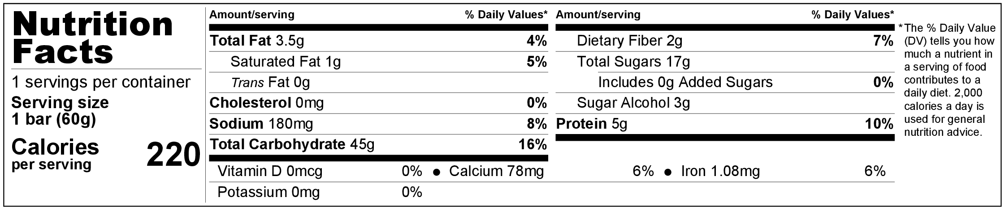

*Figure 1: Re-Created Nutrition Facts of Given Energy Bar*

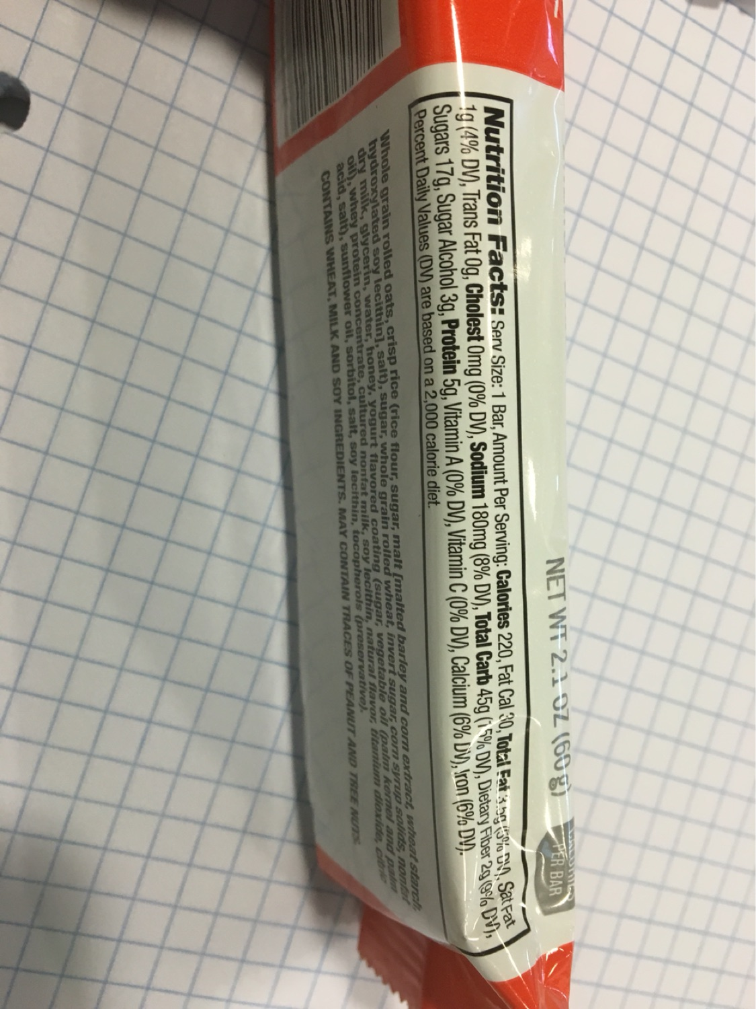

*Figure 2: Image of Nutrition Facts of Given Energy Bar*

Using these nutrition facts and the list of ingredients, whose nutrition facts were found on the USDA Food Composition Database, a spreadsheet of an estimation of the amounts of each ingredient in the energy bar was created. The nutrition facts for each ingredient that were listed in the bar were recorded and the program ran an equation to estimate how much of each ingredient was used in each bar. Though the modeling program was imperfect, there was very little error between the real nutritional data and that of the modeled formula, which totaled 0.191%. Figure 3 shows this spreadsheet.

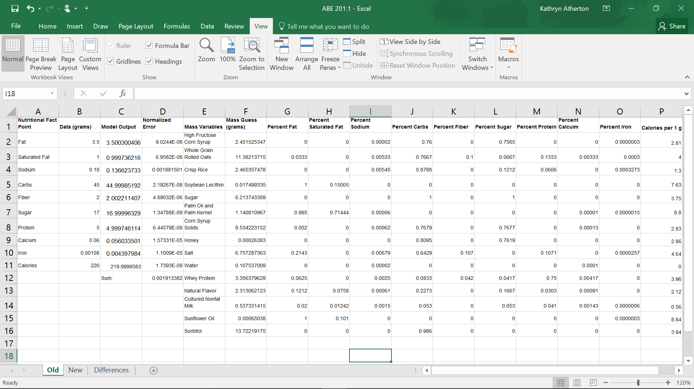

*Figure 3: Ingredients Estimation Spreadsheet*

Once the formula was determined by the spreadsheet, a new nutrition label was created for the modeled formula.

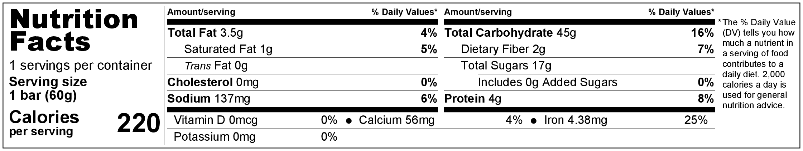

*Figure 4: Nutrition Facts of Modeled Formula for Given Energy Bar*

To improve the nutritional value of the bar, the sweetening elements of the bar--high fructose corn syrup, sugar, honey, and corn syrup solids--the crisp rice, the salt, and the nonfat milk were substituted due to their high levels of sugar and sodium. The sweeteners were substituted with agave nectar, as it is so sweet that only one-half to two-thirds of what the traditional ingredients require is necessary to create the same sweetness. The crisp rice was substituted for quinoa, as quinoa has fewer carbohydrates and more fiber. The salt was replaced with Diamond Crystal Salt Sense, as this type of salt is less dense than normal salt, and contains 33% less sodium than normal salt, while still adding the same amount and type of flavor to the bar. Finally, the nonfat milk was substituted for coconut milk, as it contains less sodium and more protein. These changes were modeled in a new spreadsheet, which can be seen in Figure 5.

A new nutritional label, Figure 6, was created for the improved bar’s formula.

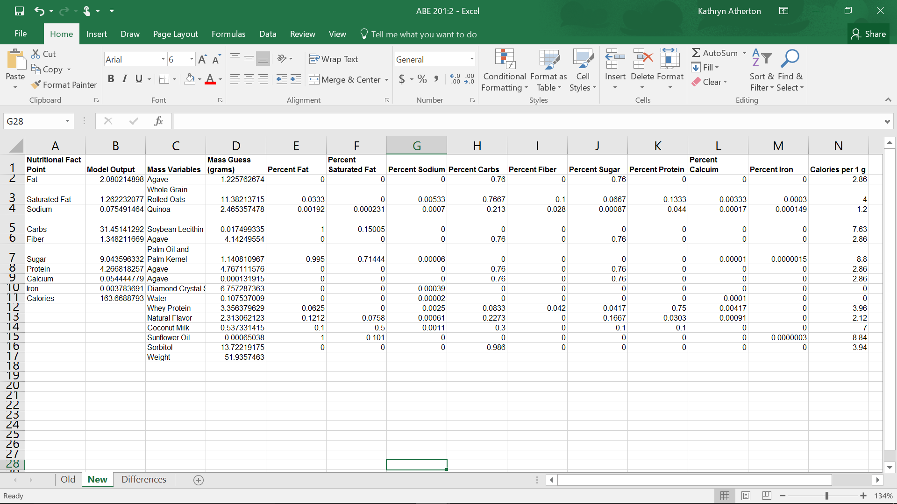

*Figure 5: New Bar Nutritional Facts Modeling*

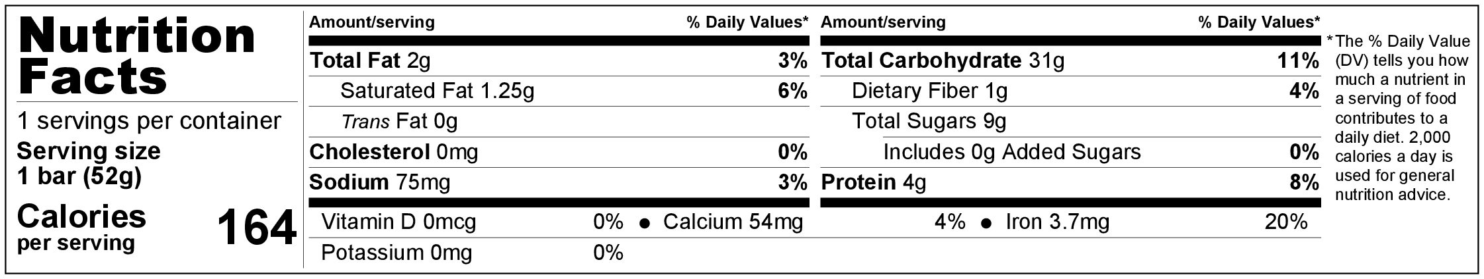

*Figure 6: Nutrition Facts of Improved Formula for Given Energy Bar*

Changes were made to the bar’s formula to reduce the amount of carbohydrates, especially sugar, in the bar. A table of the differences in nutritional values can be found in Table 2. Last year, the FDA recommended capping sugar intake to 50 grams per day due to the high rate at which Americans consume it and its presence in nearly every processed food in the nation (Rabin). Efforts were also made to reduce the amount of fat in the bar; however, with the changes, the amount of fiber, protein, and minerals also declined. The changes made reduced the weight of the bar by 13%. At first glance, the new bar does not appear to be of greater nutritional value than the original bar, but upon further inspection, it proves to provide the body with a greater nutritional value to weight ratio. The daily percentages of sodium and carbohydrates were greatly decreased, whereas the percentage of protein was only slightly decreased. This is important because daily percentages of sodium and carbohydrates are often met by consumers, while protein is not.

*Table 2: Differences in Nutritional Values between Original Bar and Improved Bar*

|  |  |  |
| --- | --- | --- |
|  | Difference | Percent Difference |
| Weight | -8.06 grams | -13% |
| Calories | -56.3 calories | -26% |
| Fat | -1.42 grams | -41% |
| Saturated Fat | +0.25 grams | +26% |
| Sodium | -0.06 grams | -45% |
| Carbohydrates | -13.55 grams | -30% |
| Fiber | -0.65 grams | -33% |
| Sugar | -7.96 grams | -47% |
| Protein | -0.73 grams | -15% |
| Calcium | -0.001 grams | -3% |
| Iron | -0.0006 grams | -14% |

Regular granola bars only contain about 1 g of protein while energy bars contain from 10-20 g of protein per bar (Adams). Some energy bars are fortified with vitamins and minerals such as calcium, iron, Vitamin C and others while plan granola bars usually just contain small amounts of vitamins and minerals (Adams). However, it is still highly depend on the manufacturer. The group’s modified bar has more protein than a normal granola bar but less than a high energy protein bar since there is only 4 g of protein in the bar. The modified granola bar also only has small amounts of Calcium, no Vitamin D and no Potassium. Iron is the only mineral that has a reasonable amount in the bar, which is 4 mg, 20% of the daily intake value. Looking at the ingredients the granola bar has, one can conclude that it does not have a lot of fortified vitamins and minerals. All these observations allow one to conclude that the given bar is not a energy bar.

Since the bar is a normal granola bar, the team’s goal is to reduce the amount of sugar while trying to keep the nutrition in the bar. After substituting some ingredients, the amount of sugar was successfully lowered. Even though the mass also decreased, the modified bar had a better nutrients-to-weight ratio than the original bar. However, to improve the bar even more, more fiber should be added. Looking at the statistics, 33% of fiber was lost from the original bar. The fiber is an important aspect of nutrition in a granola bar; thus, this would be a good improvement to focus on.

Soybean lecithin and sorbitol were identified as the two hardest ingredients to obtain. Soybean Lecithin is a generic term to designate a variety of naturally occurring fatty compounds found in animal and plant tissues ("What Is Sorbitol?"). It is composed of choline, fatty acids, glycerol, glycolipids, phospholipids, phosphoric acid and triglycerides lecithin. The main use of soybean lecithin is to help the product have a smooth and uniform appearance. As for sorbitol, it is a slow-metabolizing sugar alcohol derived from fruits, corn and seaweed (Axe). It’s a sugar substitute (sweetener) in food and it is only about 60% as sweet as sugar. It is cheaper than sugar, so it is used often in food products.

Most of the sugar was changed to agave. Looking at the data, the mass of agave in the new bar is almost 10 g. There was 2.34 g of High Fructose Corn Syrup, 6.2 Sugar and 9.5 Corn Syrup Solids in the original bar. All of these nutrients were converted into 10 g of agave, which contributed to the decrease of mass of the improved bar.

There are many pros and cons to changing the bar as proposed. Consumers today are looking for a cheap bar which tastes good. Keeping these two qualities of a bar in mind, the main substitutions were made around the sugar used in the bar. All artificial and controversial sugar sweeteners were substituted. Agave syrup was decided upon to be the substitute, which is 40% sweeter than generic table sugar ("Weight Management Friendly."). This is because the agave syrup has a higher fructose concentration compared to generic table sugar and high fructose corn syrup. Agave also appeals to people who are vegan and vegetarian. This is because it is a natural product which does not go through any processing exposing it to animals. From the website, agavenectar.com, the price of 628lbs of agave is $1500, including shipping. This equates to $2.38/lb. High fructose corn syrup costs $118.51 for 50lbs according to americanspice.com. This adds up to $1,488.49 for 628lb, or $2.37/lb. These prices are comparable, meaning agave is a viable substitute for high fructose corn syrup. Agave being 40% sweeter than high fructose corn syrup means less agave can be used than the original recipe called for for high fructose corn syrup, lowering the price even more.

Quinoa was substituted for the crisp rice in the bar. Quinoa will add more texture and density to the bar, increasing the meal replacement perks of the bar. As with agave nectar, quinoa is vegan and vegetarian while being very high in fiber and low in carbs. Wholesale quinoa was found at ifsbulk.com for $1.46/lb. Compared to puffed rice, priced at $.43/oz at walmart.com, or $6.94/lb. Wholesale pricing was difficult to find for the rice. Much cheaper rice could be bought, but with this data quinoa is economically viable. Quinoa is not as tasty as crisp rice, so that is deterrent to the product.

The next ingredient which was changed was salt. Normal iodized salt was replaced with Diamond Crystal Salt Sense Iodized Salt. This salt is $1.77/lb from Target.com. Normal iodized salt is priced at $.33/lb from webstraunt.com. This price increase will also hurt the economics of the bar. The increase will cause an increase in the price of each bar in order to maintain profit margins. Once again, finding a wholesale price for the Diamond Crystal Salt Sense was difficult, opening doors to lower prices if the right information was obtained.

The last ingredient change was coconut milk for nonfat milk. The price of coconut milk powder is $5/lb according to ranchoalegrefarm.com. Dry nonfat milk is $5/lb according to a retailer on alibaba.com. These prices are exactly the same, giving our product a competitive edge with natural and whole food markets.

Overall, the costs of the bar have remained about the same, though leaning towards a higher price. This will be combatted by the ability to charge a higher price for the natural and whole foods aspect of the improved bar. The bar will taste better than the first version because the artificial and bland ingredients have been removed for more appetizing ingredients.

The following process will produce approximately 4,000 bars per hour, or 96,000 bars per day, assuming that there are no maintenance interruptions. It begins with two mixing processes which occur simultaneously. The dry ingredients (specified on the process diagram in Figure 7) will be mixed separately from the wet ingredients (Figure 7) have been estimated to require approximately five minutes to mix completely. These two mixtures are then combined and mixed for approximately 5 additional minutes until homogenous. The mixture is then laid and pressed into flat sheets, a task that requires 30 minutes. The sheets are then cut into bar sizes. Because the sheets need to be cut vertically and horizontally, this process takes about 20 minutes. At this point, the bars will be placed in ovens to bake at 325°F for 20 minutes. It has been estimated that packaging will take an additional 20 minutes. Below is a simplified version of the process.

* Mixing Separate: 5 minutes (simultaneously)
* Mixing Together: 5 minutes
* Laying/pressing: 30 minutes
* Cutting: 20 minutes
* Bake: 325ºF 20-25 minutes
* Packaging: 20 minutes
* 96,000 bars/day

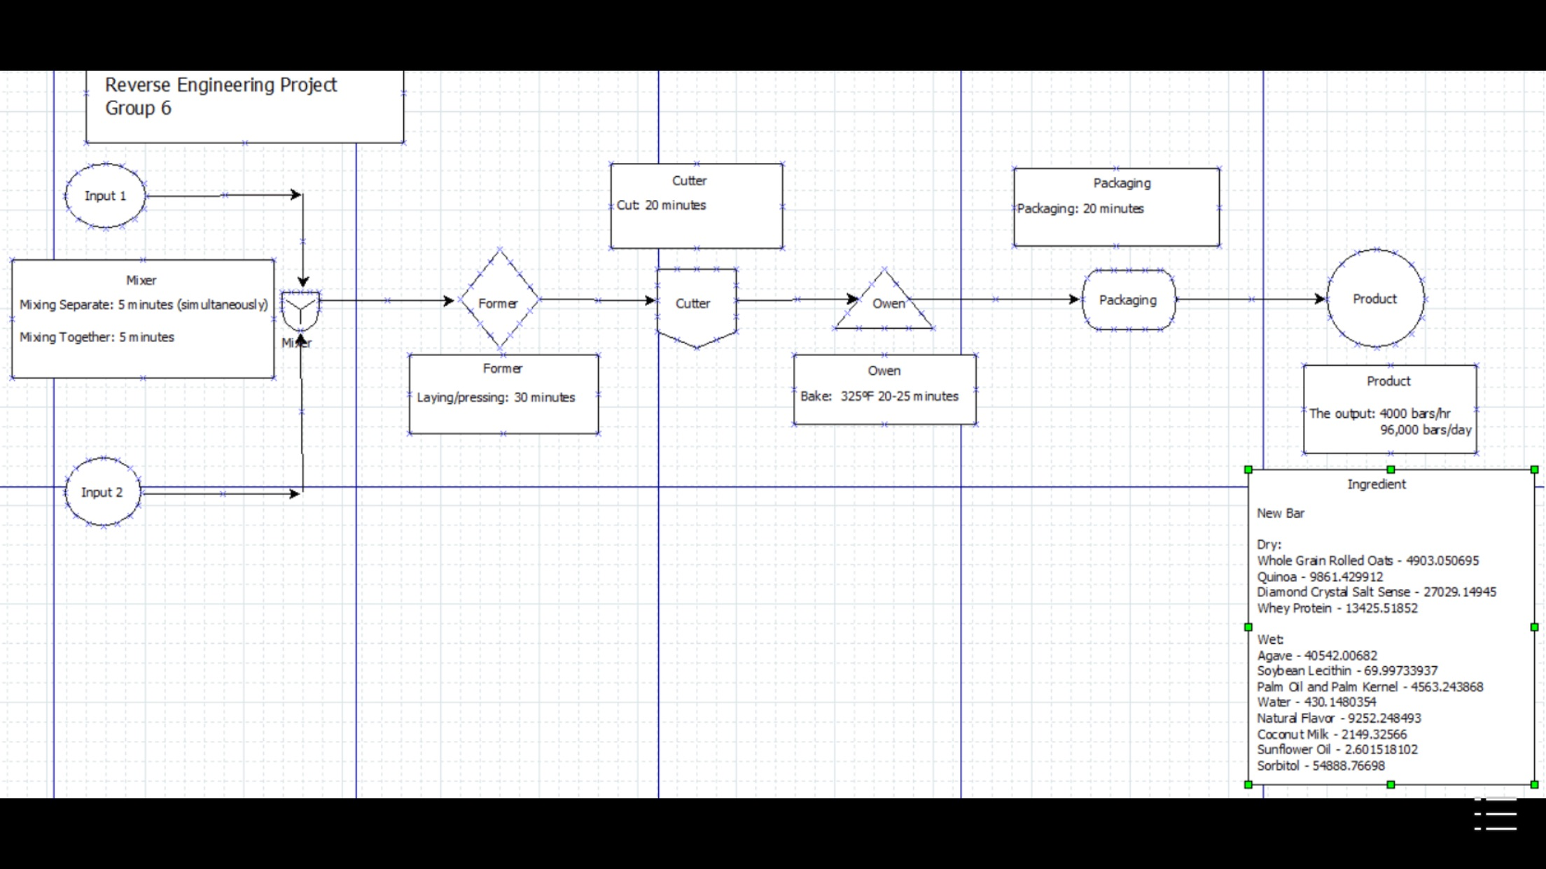*Figure 7: Process Flow Diagram*

**Bibliography**

Adams, Lawrence. "Http://www.livestrong.com/article/548682-difference-

between-an-energy-bar-and-a-granola-bar/." Livestrong. N.p., 28 Jan. 2015. Web. 2 Oct. 2016

"Agave Nectar-Wholesale Store-Prices INCLUDE the Cost of Shipping!" Nekutli Agave

Nectar RSS. N.p., n.d. Web. 03 Oct. 2016.

Axe, Josh. "What Is Soy Lecithin?" Dr. Axe Food Is Medicine. N.p., n.d. Web. 2 Oct.

2016.

By Occasion. "Food." Walmart.com. N.p., n.d. Web. 03 Oct. 2016.

By : Relevancy Transaction Level Response Rate. "Nonfat Dry Milk." *Nonfat Dry Milk, Nonfat*

*Dry Milk Suppliers and Manufacturers at Alibaba.com*. N.p., n.d. Web. 03 Oct. 2016.

"Corn Syrup Solids." Great American Spice Company. N.p., n.d. Web. 03 Oct. 2016.

L., Tonya, Erica D., Selina S., Sharon T., Athena L., Brenda M., Evan B., James B.,

Matthew P., Thomas W., Luciana T., Merve C., Shana E., Bethany S., Tom M.,

Eric L., Richard G., Sharon D., Rachel Y., Daphne M., Roelh L., David D., and

Randall H. "Morton 4 Lb. Bulk Iodized Table Salt." WebstaurantStore. N.p., 2016.

Web. 03 Oct. 2016.

"Quinoa White 25 Lb. (1 Pcs Case)." IFSBulk.com. N.p., n.d. Web. 03 Oct. 2016.

Rabin, Roni Caryn. "Placing a Cap on Americans' Consumption of Added Sugar." Web log post. Well. New York Times, 9 Nov. 2015. Web. 13 Sept. 2016.

"Target : Expect More. Pay Less." Target : Expect More. Pay Less. N.p., n.d. Web. 03

Oct. 2016.

"USDA Food Composition Database." N.p., n.d. Web. 12 Sept. 2016.

"Weight Management Friendly." All About Agave. N.p., n.d. Web. 03 Oct. 2016.

"What Is Sorbitol?" WiseGEEK. N.p., n.d. Web. 2 Oct. 2016.